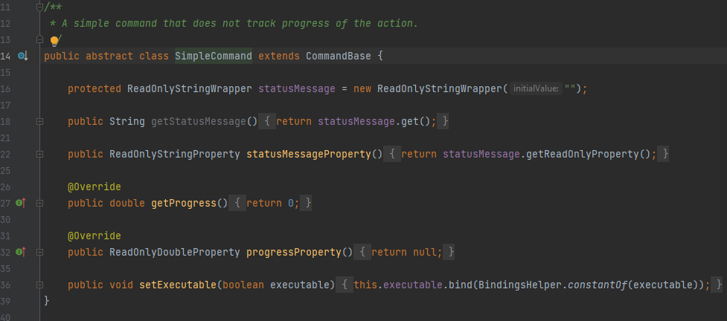
This code is located on src/main/java/org/jabref/gui/actions/SimpleCommand.java
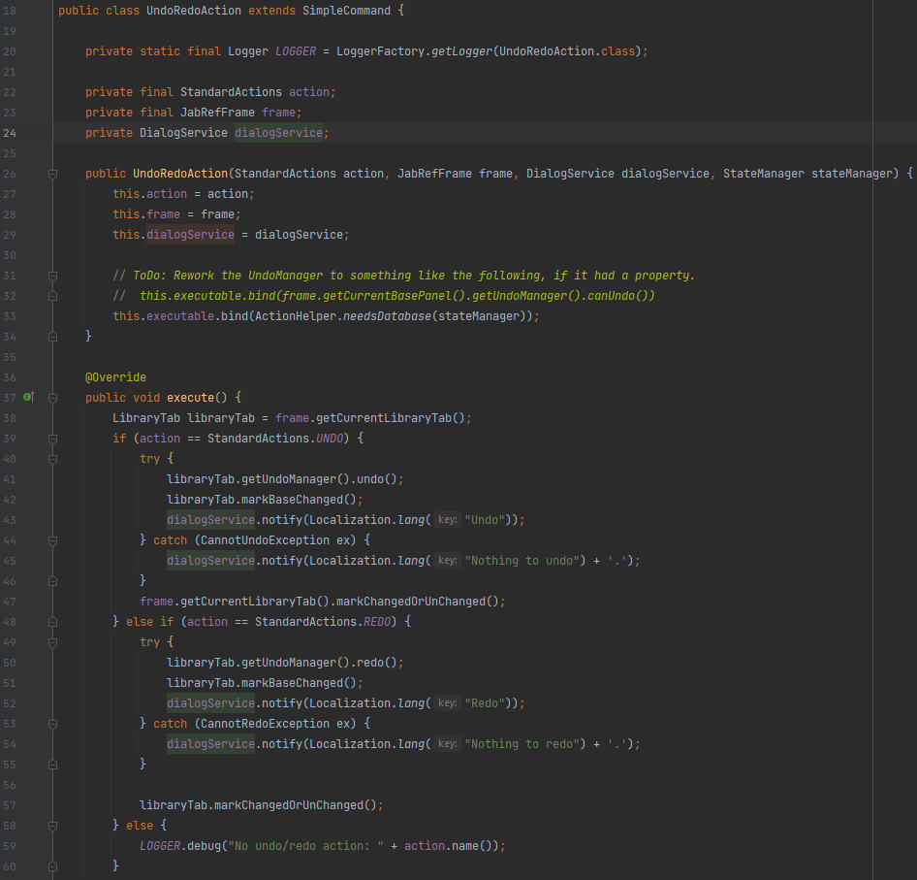
This code is located on src/main/java/org/jabref/gui/undo/UndoRedoAction.java
This is an example of the command pattern where the work is delegated from, in this case, the abstract class to a subclass which executes the command.

